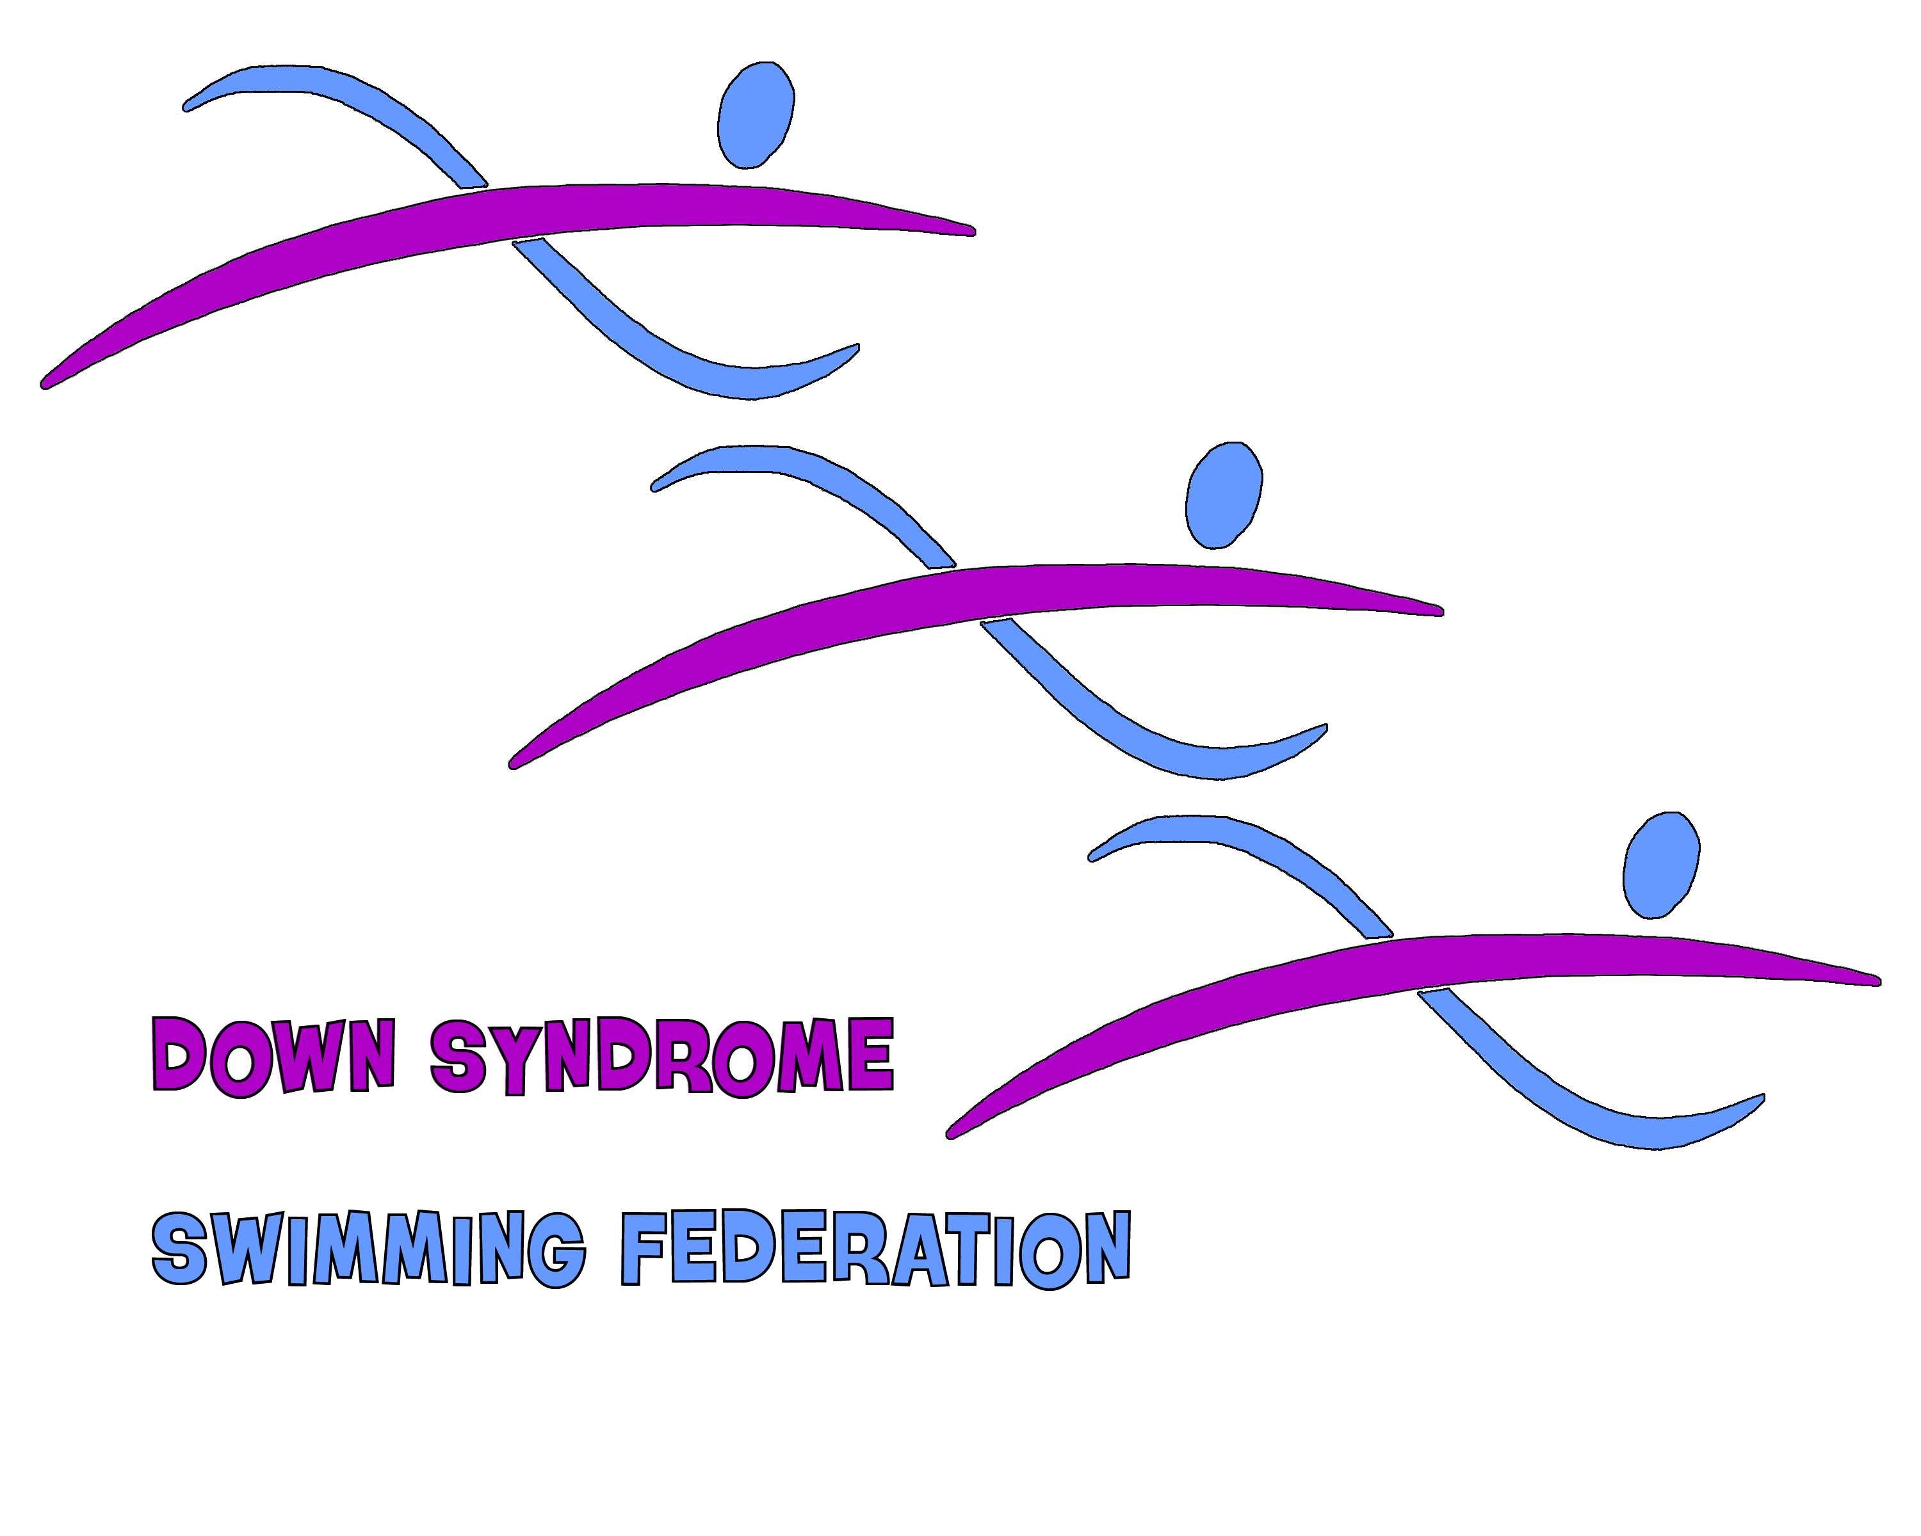

European Down Syndrome Open Swimming Competition 2019
Short Course – 25 metres
Saturday 6th April & Sunday 7th April 2019
THE QUAYS SOUTHAMPTON ENGLAND
In Association with:
Down Syndrome International
and
International Mosaic Down Syndrome Association

DSSF is affiliated to the Amateur Swimming Association

Down Syndrome Swimming Federation
Affiliated to the Amateur Swimming Association
In early 2009 it was recognized that there was a clear lack of fair and well organized competitive opportunities specifically for swimmers with Down Syndrome. Here we go again for 2018 with yet another exciting opportunity for athletes with Down Syndrome to compete against each other in a spirit of equality and harmony.
It is our stated intent, indeed in line with the ASA view of inclusivity and participation, that we are opening this event up to ANY person with Down Syndrome who is physically capable of swimming, and has the desire to take part. The minimum age is 10yrs old, again to maximize the participation element. Note also that we have changed the way we ask you to declare atlanto-axial instability, making it much easier to swim anything except butterfly and/or start with a dive, which continue to have some safety restrictions. We have 1500m and 800 Freestyle events in session 1. But we must have a minimum of 6 swimmers and swimmers must have completed the swim in 30 minutes.

Our principal challenge remains as before – money!! Unfortunately we do need more to be able to present a good competition for you this year and indeed in future years – so if you can find any financial support for us then both you and they will receive our thanks.

DSSF is recognized by Down Syndrome International and International Mosaic Down Syndrome Association as being the principal providers of quality swimming competition for swimmers with Down Syndrome, its views and aims are supported by English Federation Disability Sports (GB) and Special Olympics and we are proud to declare that DSSF is directly affiliated to the Amateur Swimming Association, creating a clear link to Fina, the world governing body of swimming.
DSSF commits to providing quality, “no frills” competition, where the whole value is invested in providing a first class swimming competitive opportunity complete with national and international technical officials, Fina approved timing systems and a world class meet management team.
All we need to make each of our events a success is the willingness and enthusiasm of the swimmers, their families and supporters and the coaching teams.
We would like to thank HY•TEK Sports Software who are our main sponsors for this year and Gosport & Fareham Football League.

Organising Group, DSSF



***RULES CONDITIONS AND INFORMATION. ******
TEAM MANAGERS/INDIVIDUAL ENTRIES PLEASE ENSURE YOU READ ALL THE CONDITIONS AND INFORMATION.
- The competition will be held under Fina Rules.
- The event is open to any swimmer with Down Syndrome (including Trisomy 21 and Mosaic Down Syndrome)
who meet the age rule.
- Swimmers must be a minimum of 9yrs as at 31 December 2019.
- The One Start Rule will apply.
- Entries cannot be processed without correct entry fees £7.50 per event.
- Pool Passes for Team Staff will be £8.00 (to a recommended maximum of 1 Staff per 4 swimmers)

        - Warm up for Session 1 will commence at 10.00 on Saturday 6th April 2019 this will be for the swimmers
swimming the 1500m & 800m Freestyle only (we must have a minimum of 6 swimmers for the 1500m &
800m Freestyle event)

Down Syndrome
The competition is open to any swimmer meeting the age conditions who can verify that he or she has the medical condition known as Down Syndrome. In order to be able to confirm this at the event, all swimmers are required to sign the Entry Form stating that they do have Down Syndrome.
There is a condition which may affect individuals with Down Syndrome known as Atlanto-Axial Instability (AAI), if this exists it may affect the safety of a swimmer with regard to dive starts and performing the butterfly stroke.
Diagnosis of AAI is undertaken by medical staff using neck x-rays and also by the recognition of other physiological symptoms. AAI may be diagnosed as symptomatic AAI, asymptomatic AAI or indeed as “clear of AAI”. To ensure that competitors are safe the promoter insists that the relevant areas of the Entry Form are completed correctly, and that team staff, parents or carers either bring or send with the competitor’s entry forms medical documentation supporting the declared diagnosis with them.
Individuals with a diagnosis of symptomatic AAI will NOT be permitted to enter.
Individuals with asymptomatic AAI must have a statement clearly stating that there is no restriction on the named person competing in a swimming event. If a swimmer with asymptomatic AAI is to be entered into a Butterfly event or to dive start then the named individual must provide a signed declaration from a medical practitioner that it is safe for that individual to swim butterfly and/or start with a dive.
Entry Fees
Entry Fees will be £7.50 (GB Pounds) per swimmer per event entered £8 Team/Support staff.
FULL PAYMENT IS TO BE MADE BY CHEQUE DRAWN ON A BRITISH BANK (IN BRITISH POUNDS) MADE PAYABLE TO DOWN SYNDROME SWIMMING FEDERATION OR BY ELECTRONIC TRANSFER
THE PAYEE IS RESPONSIBLE FOR ALL BANK CHARGES.

Bank Name: Santander
Account Name Down Syndrome Swimming Federation
Account Number 24109987
Sort Code 09 01 27
BIC ABBYGB2LXXX
IBAN GB10ABBY 0901 2724 1099 87
Events will be swum in the following order, there are no limits on the number of events that may be entered, however the Promoter reserves the right to limit or decline Entries on the basis of time available should the Event be over-subscribed.

Entries should be e-mailed to dseuroswim@gmail.com with full details of swimmers names, events and submitted entry times. Please also include details of how payment is being made.
This e-mail is to be followed by the paper copy of the completed entry form by mail to the address on the entry form. Please note that the entry form must be fully completed, incomplete entry forms may be rejected.
Programme
Saturday 6th April
Session 2
Warm Up 14.30
Start 15.00

Saturday 6th April
Session 1 A
Warm Up 10.00 Swimmers swimming
1500m & 800m only
Start 10.20am

Warm Up for second session will commence on
Completion of the 800m
Session 1 B
Start 11.00am approximately

50m Backstroke | Female
50m Backstroke | Male
200m Butterfly | Female
200m Butterfly | Male
100m Breaststroke | Female
100m Breaststroke | Male
200m Freestyle | Female
200m Freestyle | Male
25m Breaststroke | Female
25m Breaststroke | Male
100m Individual Medley | Female
100m Individual Medley | Male

50m Breaststroke | Female
50m Breaststroke | Male
400m Freestyle | Female
400m Freestyle | Male
200m Backstroke | Female
200m Backstroke | Male
25m Backstroke | Female
25m Backstroke | Male
50m Freestyle | Female
50m Freestyle | Male
100m Butterfly | Female
100m Butterfly | Male
25m Butterfly | Female
25m Butterfly | Male
4x50m Freestyle Team Heats | Mixed

Sunday 7th April
Session 3
Warm Up 09.30
Start 10.15

Event entries will be strictly Time Banded. – The success of the Gala depends on accurate swim times being
50m Butterfly | Female
50m Butterfly | Male
200m Individual Medley | Female
200m Individual Medley | Male
100m Backstroke | Female
100m Backstroke | Male
200m Breaststroke | Female
200m Breaststroke | Male
25m Freestyle | Female
25m Freestyle | Male
100m Freestyle | Female
100m Freestyle | Male
4x50m Freestyle Team Final | Mixed
submitted. Should any swimmer swim more than 15% faster than their Entry Time then they will be given a
“speeding ticket” and excluded from the placings for that Race. Where there are only enough entries for one
heat, and also in the fastest (final) heat of any event, there will be no time banding and the 15% rule will not
apply.
- All swimmers must submit dive start forms, AAI and medical forms with entry forms.
  - It will be swum with males and females swimming separately, unless the number of entries requires them to
  - swim together.
  - Swimmers must report to the Competitors Stewards at least four (4) races before the start of their event,
  - swimmers will not be called or waited for if they are not present.
- Swimmers must swim in the lane that has been allocated to them unless requested to change by the Referee.
- Any swimmer who requires the use of the hoist or has a medical alert and needs an outside lane please
inform us on the entry form

Team Managers and Individual Entries (swimmers); please report/register upon your arrival to the registration clerks in the foyer. If you do not report/register you may miss your event if heat sheets have been generated.

REGISTRATION WILL BE AS FOLLOWS:
This will be for withdrawal of swimmers only
Saturday 09.15 to 10.00
Sunday 09.00 to 09.20

CLOSING DATE FOR ENTRIES Wednesday 28th March 2019

A provisional start list will be sent to Team Managers or individual entrants to check their competitor/s events and times to ensure they are correct all changes must be reported no later than Monday 1st April 2019.

There will be no changes on the day of competition.

- The Promoters may take photographs/recording of you at this event. These images may appear in publicity
material or websites. The organisers will only use appropriate images of athletes to promote sport and
recreation and/or athletes in competition through publicity material, media, contacts or other appropriate means
and will not include personal email, postal addresses or telephone/fax numbers. Your approval of entry
indicates approval for such photography/recording to take place.

Team Managers and Individual Entries (swimmers) will receive competition start sheets
- Programmes will be available at the door, A CHARGE WILL BE MADE FOR ENTRY
- Raffle tickets will be sold at the door
- Withdrawals will not be refunded.
- The promoters have the right to refuse entries.
- Lifeguard cover will be provided throughout the competition.
- Pool hoist is available, if required (please inform on entry form).

POOL AND POOLSIDE SAFETY
- FIRE EXITS are clearly marked. Everyone attending must ensure that they familiarise themselves with these
exits in case of any emergency. A copy of the Pools NOP’s and EAP’s will be available upon request from the Leisure Centre Reception Desk.
- Team Managers/Individual swimmers shall satisfy themselves that their swimmers/individuals are competent to the standard of the ASA Competitive Start Award or Dive Start requirements detailed in this Entry Pack. Any swimmer who is not competent must start from the poolside or in the water. In the event of a false start swimmers must execute a shallow racing dive. They must not topple in head-first as this is dangerous.

Depth at Shallow end. 1.2m.
Depth at Deep end. 2m.
The width of the pool: 12.5m.
Length of Pool: 25m.Registered as surveyed by British Swimming
Omega ARES 21 Electronic Timing
Nationally Qualified Referees and technical officials
- NO DIVING FROM THE SHALLOW END OF THE POOL WILL BE ALLOWED AT ANYTIME.
- Swimmers and spectators are reminded that property should not be left unattended at any time. The Promoter
cannot accept liability for any loss or damage that may occur.
- To use the lockers in the changing rooms swimmers will need change
    - We encourage all parents to come and support the event, however please note that spectators will not be
    - permitted access to the poolside. No smoking or alcohol is permitted in any areas to be used by athletes.
- All competitors are required to ensure that they have adequate Insurance cover for all eventualities.
- Any matter not covered above will be decided at the discretion of the Meet Director who also reserves the right
to make any changes that may be considered necessary for the smooth running of the event.

Spectators will be charged an entry fee, a raffle will be run
Should you have any queries regarding the above, please do not hesitate to contact the Promoter by e-mail at dseuroswim@gmail.com
We look forward to receiving your entry(s)
dseuroswim@gmail.com
We would prefer all entries to be made by e mail but if you are unable to do this then you can send a hard copy to the following address:

Hard Copies to the following address
61 Mandarin Way
Howe Road
Gosport
PO13 8DP
Hampshire
England

Atlanto-Axial Instability, Dive Start and Butterfly

Atlanto Axial Instability (AAI) is a condition which is occasionally present in people with Down Syndrome, and is a matter that must be taken into account when considering swimming in any form, and particularly diving from the side into water or swimming the butterfly stroke.

For this competition we require to ensure that all athletes are as safe as possible, whilst still encouraging the maximum number of swimmers taking part, therefore we are only asking for very limited checks and only applying limited restrictions.

AAI diagnosis is often undertaken by neck x-ray and/or by the presentation of certain physical symptoms. If in any doubt you MUST consult a medical practitioner.

Symptomatic AAI – If a swimmer has been diagnosed with symptomatic AAI then we will not accept the Entry. It is considered that the risk of injury is high and it is not safe for the individual concerned to take part.

Asymptomatic AAI – If a swimmer has been diagnosed with asymptomatic AAI then do as follows:
- For Butterfly events – A medical practitioner is to sign a statement that it is safe for the individual
swimmer to compete in a Butterfly event
- To start with a dive from the side or block - A medical practitioner is to sign a statement that it is safe for the individual to start with a dive from the side or block
- If NOT competing in Butterfly or with a dive start then a signed authorization from a parent or carer is required to allow the swimmer to compete (ie for Breaststroke, Freestyle and Backstroke)

“Clear of AAI” – If a swimmer is considered to be completely clear of AAI then a signed authorization from the swimmer, a parent or carer is required to allow the individual to swim in any stroke.

Starting with a Dive.

Many swimmers like to start their race with a dive from either the side or from a starting block. Generally this is a safe activity, however if it is not done properly then it can be slower than starting in the water, painful or potentially cause injury to the neck or back.

To make sure that the swimmer is safe to dive, as well as following the guidance on AAI above, we require to have a signed confirmation that the swimmer meets a simple set of guidance set out in the section titled “Dive Start Guidelines -Minimum Performance Requirements”

Dive Start Guidelines -Minimum Performance Requirements
These Guidelines have been drawn from those in use by British Swimming to encourage safety when considering the dive start and from Fina Guidelines regarding depth of competition pools.
Assessment and validation is to be made by a swimming coach or swimming trainer.
Dive Start Test (Side)
The depth of water is to be a minimum of 0.9m and a maximum of 1.5m, with a maximum freeboard of 0.38m
The athlete is required to demonstrate that he/she is capable of performing the following activities from the Poolside under normal starting conditions in a proficient and safe manner.
- Perform a shallow dive followed by a glide of at least 5m.
- Perform a shallow dive followed by a front crawl leg kick to surface
- Perform a shallow dive followed by a dolphin leg kick to surface
- Perform a shallow dive followed by one breast stroke arm pull and leg kick to surface
- Perform a track, grab or wind-up start followed by a glide for 5m

Dive Start Test (Block)
This additional assessment is to ensure that the athlete has confidence in the use of the Block in achieving a dive start.
The depth of water is to be as minimum of 1.35 and a maximum of 2.0m, the height of the Block is to be a minimum of 0.5m and a maximum of 0.75m above the water surface.
In addition to the requirements of the Dive Start Test (Side), the athlete is required to demonstrate that he/she is capable of performing the following activities from the Block under normal starting conditions in a proficient and safe manner.
- Perform a shallow dive followed by a glide of at least 5m.
- Perform a track, grab or wind-up start followed by a glide for 5m
- Perform a dive start followed by a front crawl leg kick to surface
- Perform a dive start followed by one breast stroke arm pull and leg kick to surface

